Wastewater/Water Sustainable Energy Cohort of Washington
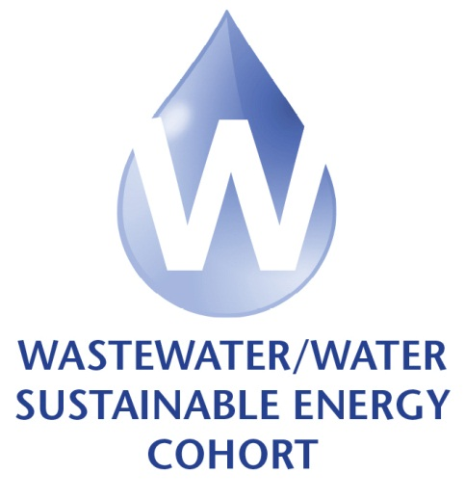
Thursday, January 31, 2013
City of Edmonds
8:00 am – 4:00 pm (break for lunch)
Each wastewater utility bring and be ready to report on:
- O&M Standard Operating Procedures (for Bob Sprick’s presentation); Completed Homework if it hasn’t been turned in; EPA Guidebook; and Laptop (optional)
Useful background information for meeting:
Meeting objective: Learn about potential sources for funding assistance for energy-related projects; learn how to improve aeration efficiency; discover additional innovative techniques for energy conservation, while engaging in cross-talk with cohort; roll energy management approach into a two-year plan.

Time | Topic/Presenter
8:00 am | Coffee & tea available…
8:30 am | Welcome and Introductions  …Phil Partington, WSU Energy
8:35 am | Tool Box Quiz  …Pamela Randolph, City of Edmonds
8:40 am | Peer Mentoring Exercise  …Layne McWilliams, Energy Smart Industrial  Discussion on what you have accomplish; what you want to accomplish; and update on homework/challenges
9:00 am | Innovative Billing Practices  …Bob Sprick, Operation Supervisor at Eugene/Springfield RWPC Facility
10:00 am | BREAK
10:15 am | Funding Opportunities for Energy Projects  …Andreas Winardi, Puget Sound Energy  …Jim Conlan, Snohomish County PUD
10:35 am | Energy Independence at WWTP  …Dawn Lesley, ESI
11:35 am | Cohort Spotlight—City of Edmonds and Chamber’s Creek  …Pamela Randolph, City of Edmonds  …Jamie Swears, Chamber’s Creek WWTP
Noon– 12:30 pm | L U N C H
12:30 pm | Improving Efficiency in Aeration  …Dave Reardon, HDR
1:30 pm | Process Push Points  …Bob Sprick, Operation Supervisor at Eugene/Springfield RWPC Facility
3:00 pm | Group Exercise and Discussion on Process Push Points  …Dorothy Atwood, Zero Waste Alliance, and Bob Sprick, Operation Supervisor at Eugene/Springfield RWPC Facility
3:20 pm | Preparing for Your Final Report  …Dorothy Atwood, Zero Waste Alliance, and Layne McWilliams, Energy Smart Industrial
3:45pm | Review of Homework  …Dorothy Atwood, Zero Waste Alliance
4:00 pm | A D J O U R N MEETING & Beginning of WWTP Tour

Session #5 Assignments/Takeaway
- Work on master calendar
- Ongoing energy measurement- How?
- Maintain Opportunities register
- Ongoing training and engagement
- Review and update of goals
- Start final reporting master reporting form

