FEDERAL FACILITY ASSESSMENT GUIDE

**Motor Assessment Guidance**

**General Motor Assessment Tasks:**

1. Write down motor name plate data *(using NREL input forms)*
2. Write down operational hours per day, week, month

**Constant Volume Fans and Pumps:**

1. Write down motor name plate data *(using NREL input forms)*
2. Measure voltage (Volt) and operating current (Amps)
3. Calculate motor a hand held amp/voltage meter with the following equation

* For long term load calculations, a current transformer can be installed to calculate AMP load over time *(Note: For constant volume fan and pump systems a calculation at one point in time is all that is needed, as the load will not change over time)*
* Record amperage on each phase (A, B, C) and phase to phase voltage (A-B, B-C, A-C) *(Take an average of the measured amps and voltage)*

**Motor Load Calculation**

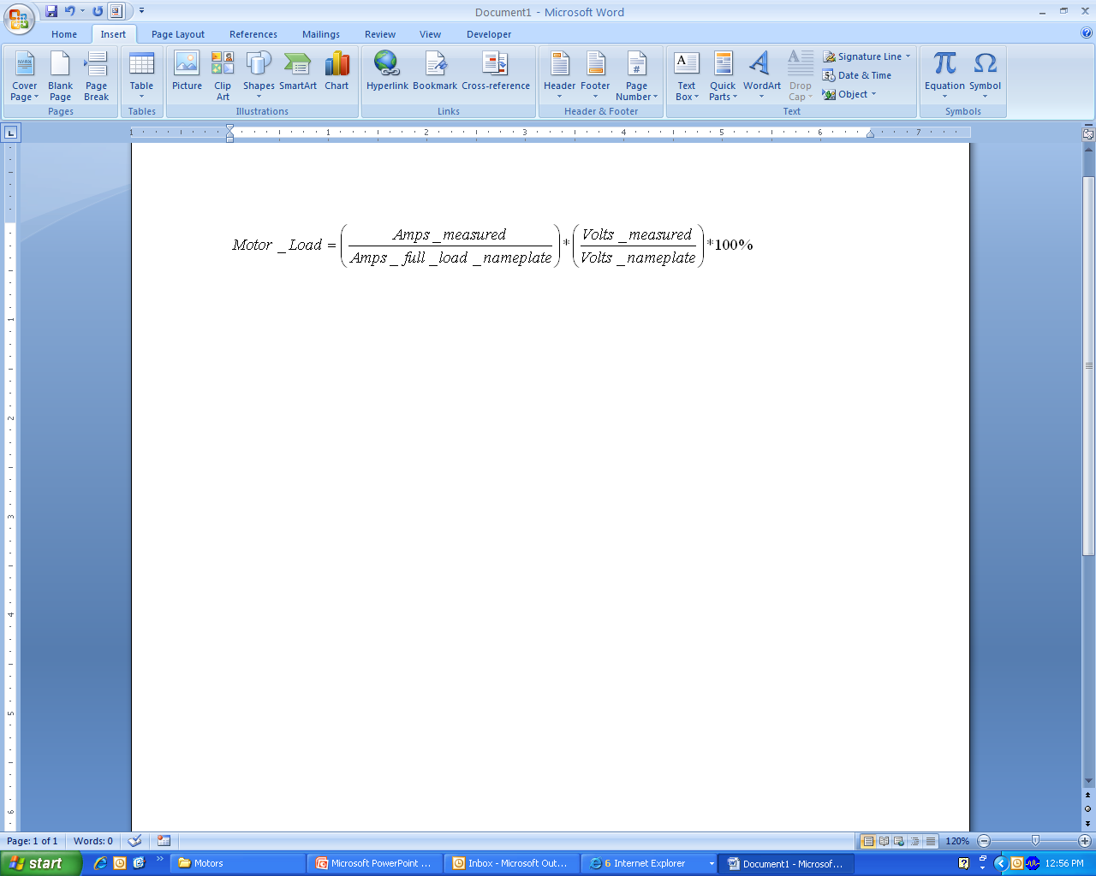

1. For fan systems record belt type *(cogged or v belt)* and the number of belts per drive

* Record pulley dimensions and distance between pulleys

**Variable Frequency Drives:**

1. Write down VFD name plate data (manufacturer, model number and specifications)
2. Record frequency and percent flow rate at time of assessment
3. Make sure the drive isn’t in ‘hand’ or ‘manual’
4. Make sure VFD display matches DDC control signal

* *Command VFD to ramp up and down through DDC control system and make sure it is controlling properly*

**NEMA Premium ODP Motors (Feb 2010)**



**NEMA Premium ODP Motors (Feb 2010)**



**NEMA Premium TEFC Motors (Feb 2010)**



**NEMA Premium TEFC Motors (Feb 2010)**



**Ultra Efficiency Motors (1-20 hp) (Feb 2010)**

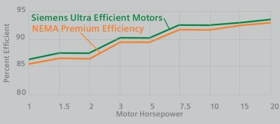

**Motor Efficiency versus Load (Feb 2010)**



**Motor Power Factor versus Load (Feb 2010)**



FEDERAL FACILITY ASSESSMENT GUIDE

**Motor Assessment Checklist**

**Replace all Standard Efficiency Motors with NEMA Premium Motors**

NEMA premium motors can reduce energy use by as much as 10%. All of the standard efficiency motors should be replaced with NEMA premium motors. For motors on centrifugal loads, a NEMA premium motor with the closest full load RPM rating should be specified. Convenient replacement times include, all new installations, when purchasing equipment packages, instead of rewinding older standard efficiency motors, when doing preventative maintenance or implementing energy conservation programs. Also consider replacing single speed motors with dual speed motors. Consider adding variable frequency drives to any AC motors that could be ramped up or down for different load requirements. If fan speed is reduced to ½ of full load speed, power usage is reduced to 1/8 of full load.

**Replace all Standard V Belts with Cogged V Belts**

Checking motor belts for proper tension and alignment can greatly deteriorate the efficiency of power transmission. Replacing standard v-belts with cogged v-belts can increase the efficiency of the power transfer by 2%-5% due to reduced bending resistance and reduced slip. Cogged v-belts can use the same pulleys as standard v-belts. All standard v-belts should be replaced with cogged v-belts.