FEDERAL FACILITY ASSESSMENT GUIDE

Lighting Site Assessment Guidance

**General Lighting Assessment Procedure:**

1. Record illuminance levels (foot-candles or lux) in various spaces using a hand held light meter

* Office light levels should be taken at desk level (standard is 30” AFF)
* Hallway measurements should be taken at the floor level and restroom measurements should be taken at counter height
* Develop a grid of points; 2’ on center for small offices and 10’ on center for large open spaces and record light levels at each point on the grid (note min, max and average light level for each space)
* Record nighttime and daytime light levels within each space. Take nighttime and daytime measurements at the same location to determine daylight contribution and note sky condition (clear, partly cloudy, cloudy). This can give a rough sense for expected annual daylight to see if fixture rezoning or other daylight measures are appropriate. *(Note: Make sure the lighting design can meet night time illuminance requirements when reducing LPD and light levels)*

1. Count lamps/ballasts in each room

* Count fixtures, lamps, and ballasts *(Fixture counts can also be approximated from electrical drawings)*
* Calculate space area and calculate Lighting Power Density (LPD) (Watts/ft2) for each space type. (Fixture wattage = lamp wattage x # of Lamps x Ballast Factor (B.F.))
* Record fixture type *(i.e. recessed, recessed vented, indirect/direct, etc.) If pendant mounted, note pendant length*
* Record ceiling height and type

1. Write down lamp data and ballast data

* Look up ballast specifications on the internet
* *Record lamp type, lamp color temperature (Kelvin), lamp wattage*
* *Record ballast type, ballast factor and program, instant, or rapid start*

1. Write down operational hours per day

* Calculate operational hours per year

1. Write down control system and wiring layout

* Look for existing occupancy sensors, dimming ballasts, and lighting control system
* Sketch out the configuration of lighting zones within the space
* Use the following table to determine acceptable reduction in ballast factor if the space is over lit. Ballast factor is proportional to light output and percent of lamp wattage.



**Retrofit and Redesign Issues:**

1. Redesign should be considered when:

* The space is undergoing a major renovation and the current fixtures are recessed direct.
* Existing luminaries provide non-uniform light distribution, and/or can’t meet illumination requirements
* Look for opportunities to re-zone the space for occupancy and daylighting control

1. For retrofit or redesign projects the new design should produce acceptable light quality:

* Maintain uniformity
* Provide for glare control
* Improve color rendering

**Recommended Illuminance (IES) and Lighting Power Density (ASHRAE 90.1version) by Space Type**



**Occupancy Sensor Assessment Tasks:**

1. To start, follow the general procedures listed above.

* Determine appropriate mounting configuration *(wall or ceiling mounted)*
* Determine appropriate sensor type *(ultrasonic, infrared or combination)*
* Determine the number of occupancy sensors per space
  + *Typical coverage range for wall mounted sensor is 300 – 400 ft2*
  + *Typical coverage range for ceiling mounted sensor is 1,000 – 2,000 ft2*
* Determine installation time
* Look for opportunities to re-wire the space into multiple smaller zones w/occupancy sensor per zone
* Determine reduction in operational hours
* Note commissioning settings (e.g., manual on and auto off)



**Daylighting Side-lighting Analysis:**

1. Calculate floor to window height (ft)

* Assume daylight from side lighting can go 1.5 to 2 times height of window into space

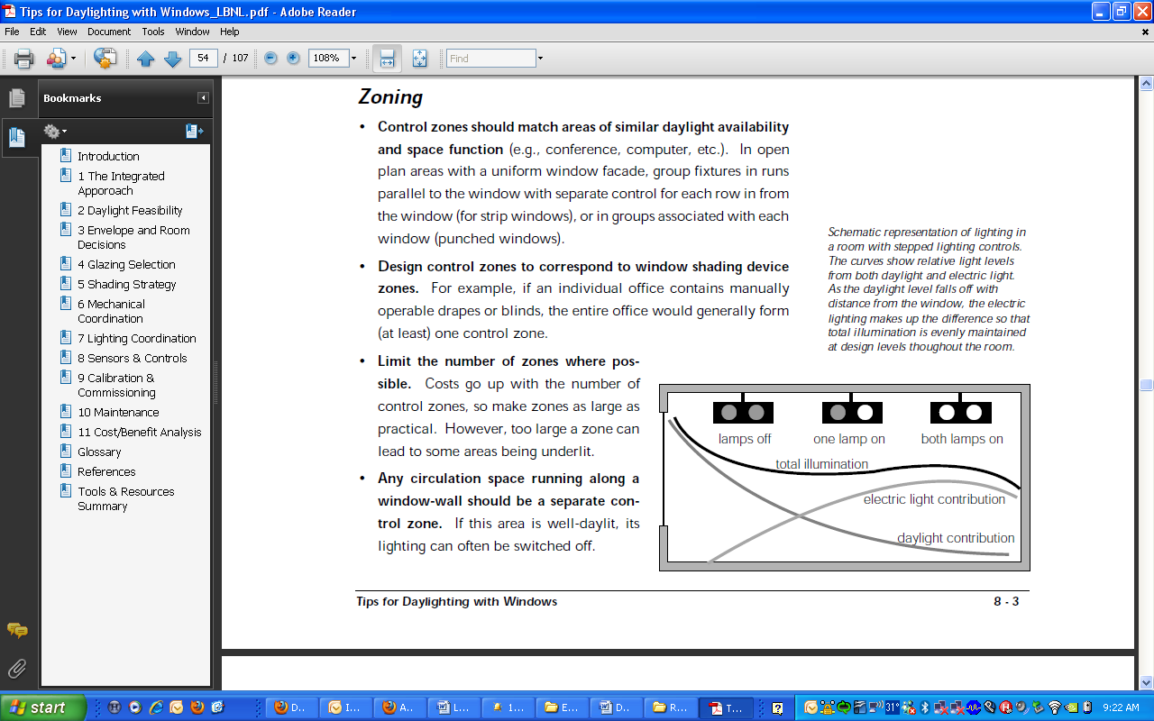

**h**

**d = 1.5 x h**

* Count the number of fixtures that are located within this area
* Record light levels next to window and make sure glare prevention (e.g., blinds) are blocking any direct sun.
* Determine rough zoning recommendations *(Model energy savings in eQUEST)*

**Daylighting Top Lighting Analysis:**

1. Calculate top floor area
2. Analyze the roof construction to determine applicability for top lighting
3. Skylight to floor area should be 3%-5%

*(Model energy savings in eQUEST)*

**Central Lighting Control System Assessment Tasks:**

1. Determine if central lighting control system is applicable (usually for larger commercial buildings)

* Count the number of lighting panels and lighting breakers per panel
* Determine the number of different lighting schedules that will be needed

**Site Assessment Tools:**

1. Use an illuminance meter to record light levels, a roller wheel or ultrasonic range finder to measure space dimensions, and a tape measure to measure floor to window height.

**50% Energy Savings over ASHRAE 90.1- 2004**

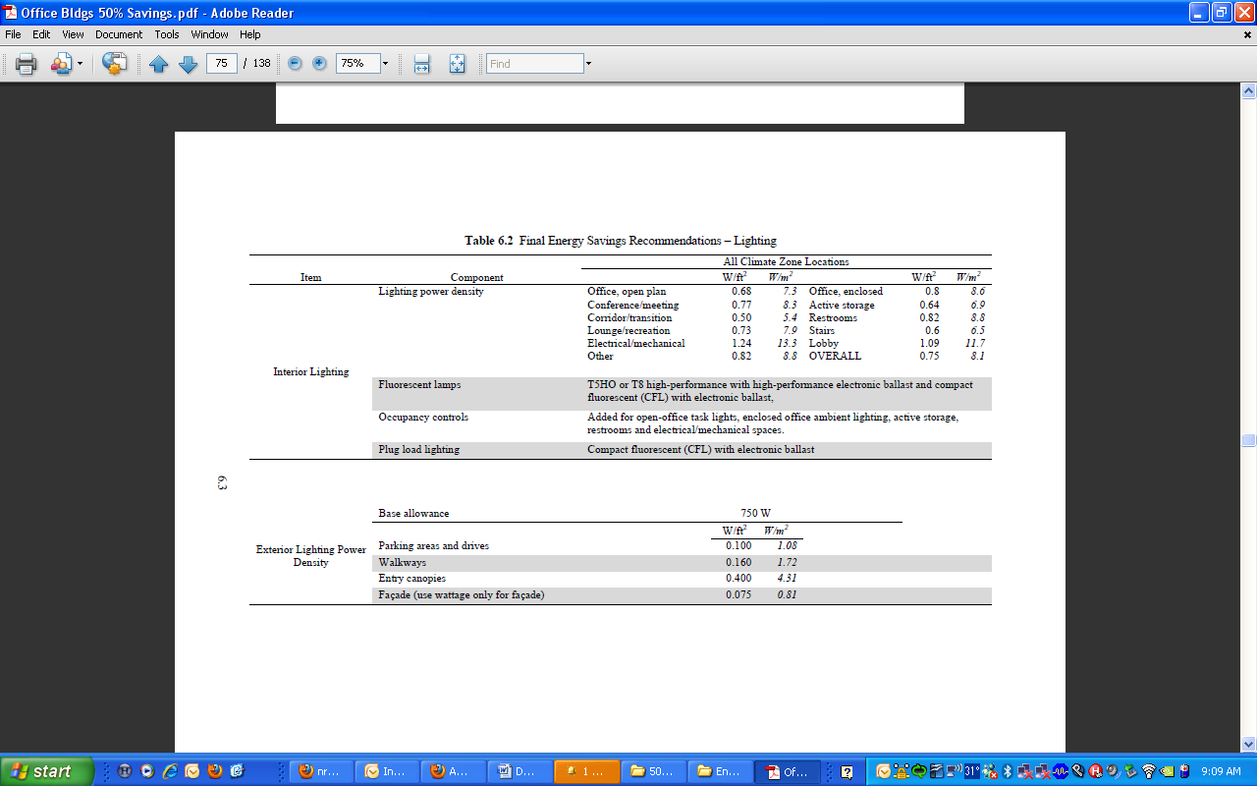

FEDERAL FACILITY ASSESSMENT GUIDE

Office Lighting Checklist

**Replace T-12 Lamps and Magnetic Ballasts with Low Wattage T-8 Lamps and Electronic Ballasts**

All T-12 lamps and magnetic ballasts should be replaced with tri-phosphor low wattage T-8 lamps and low ballast factor electronic ballasts. Tri-phosphor low wattage T-8 lamps use less energy and produce better quality light than standard T-12 lighting systems. Electronic ballasts with low ballast factors (BF<0.85­­­­­­­­) can reduce lighting system energy use by as much as 40%. Specify tri-phosphor T-8 lamps with color temperature of 4,100 Kelvin.

**Replace Standard T-8 Lamps with Low Wattage T-8 Lamps and Low Ballast Factor Ballasts**

Tri-phosphor low wattage T-8 lamps use less energy than standard 32 Watt T-8 lamps. Electronic ballasts with low ballast factors (BF<0.85­­­­­­­­) can reduce lighting system energy use by as much as 30%. If the lighting levels of the current T-8 lighting system are higher than the recommendations provided above, standard T-8 lamps should be considered for replacement with tri-phosphor low wattage T-8 lamps and low ballast factor electronic ballasts should be installed.

**Install Perimeter Dimming Ballasts**

Dimming electric lights in locations where daylight is sufficient for working purposes can significantly reduce energy use. All lamps and ballast within 10-20ft of the perimeter envelope should be capable of dimming and connected to a daylight sensor. Typical fluorescent dimming systems provide continuous dimming from 100% to 1% -10% of light output. In addition, it is important to look for opportunities to install light louvers (<http://www.lightlouver.com/>) on south facing windows and lower blinds to increase daylight contributions.

**Install Low Wattage Screw-in Lamps**

Compact fluorescent lamps (CFL) and low wattage halogen lamps use significantly less energy for similar light outputs compared to standard incandescent lamps. All incandescent and standard halogen lamps should be replaced with CFL’s or low wattage halogen lamps.

**Optimized Interior Security Lighting**

Interior security lighting should be maintained at a minimum of 1-5 fc during unoccupied times in hallways, and turned off in traditional office space during normal business hours. Non-security fixtures should be controlled by occupancy sensors.

**Replace Exit Signs with LED Exit Signs**

LED exit signs typically use 5 Watts or less, and can save significant amounts of energy when compared to standard incandescent exit signs. All incandescent and compact fluorescent exit signs should be replaced with LED exit signs which meet building and fire code requirements.

**Replace HPS/HID Garage Lighting with LED lighting**

LED garage lighting can reduce the energy usage of standard garage lighting up to 50%. All HPS/HID garage lighting should be replaced with low wattage LED lighting.

**Replace Incandescent Recessed Can Fixtures with LED or CFL Lighting**

LED and CFL lighting uses less energy and has dimmable capability and are good retrofit options for recessed can fixtures. All incandescent recessed can fixtures should be replaced with LED or CFL lighting.

**Replace Incandescent Cooler/Freezer Lights with LED Lighting**

LED lighting uses less energy, can be dimmed, and produces more light when in cold environments. All incandescent lamps in coolers/freezers should be replaced with LED or CFL lighting.

**Replace/Install under Cabinet and Task Lighting**

Task lighting can reduce the general area lighting requirements and significantly reduce energy consumption. Under cabinet and task lighting should be installed in conjunction with an appropriate reduction in general area lighting.

**Replace Outdoor Parking and Street Lights**

Current LED technologies can reduce outdoor parking/street lights energy consumption by up to 60%. All HPS or HID lamps with magnetic ballasts should be replaced with a low wattage LED lighting system.

**Install Occupancy Sensors in Bathrooms, Conference Rooms, and Private Offices**

Occupancy sensors can significantly reduce light usage during unoccupied times. Occupancy sensors should be installed in all bathrooms, conference rooms, private offices, exterior environments with intermittent occupancy and other appropriate spaces.

**Install Central Lighting Controls**

Central lighting controls can significantly reduce the operating time of current lighting circuits. Central lighting controls should be installed and commissioned according to the various occupancy schedules.

**Replace HID Magnetic Ballasts with Electronic Ballasts**

Electronic ballasts provide better lumen and color maintenance than magnetic ballasts, and have dimmable capabilities for energy savings. All HID fixtures that currently use magnetic ballasts should be retrofit with lower wattage lamps and electronic ballasts if the light levels can be slightly lowered.

**Reduce Lighting Levels on Over-lit Spaces**

Maintain code recommended lighting levels in all spaces. If some areas are over-lit, de-lamp fixtures to reduce the lighting levels and conserve energy.

**Replace Linear Fluorescent ‘Milky White’ lens with Clear Acrylic Prismatic Lens**

Clear acrylic prismatic lens allows approximately 90% of the light to pass through with a more even distribution of light. Replace all ‘milky white’ or yellowed lenses with a clear acrylic prismatic lens. These older lenses can block 20%-40% of the light output.

**Install Metallic Reflectors**

In older fixtures, if the existing metal reflector is severely degraded or missing, installing new metallic reflectors can significantly increase light output. If this is the case a lamp can typically be removed or a ballast with a lower ballast factor can be installed. When installing metallic reflectors it is important to ensure the reflector isn’t causing glare or decreasing uniformity

**Install Bi-Level Switching**

When retrofitting the lighting system within a space, look for opportunities to install bi-level switching. This gives the user the ability to reduce the number of lamps or fixtures turned on to illuminate the space.

**Redesign of a Space**

When a building is going to through a major modernization, look for opportunities to redesign the entire lighting system. Try to use an indirect/direct or fully indirect fixture with revised fixture spacing to reduce lighting power densities and provide for more uniform light distribution. Although indirect fixtures can provide for more uniform light distribution, they can also require more fixtures for the same work-plane illuminance. It is important to provide as many small zones that can be individually controlled through occupancy sensors as possible.

FEDERAL FACILITY ASSESSMENT GUIDE

High Bay Lighting Checklist

**Replace High Pressure Sodium Lamps with Pulse Start Metal Halide**

Replacing standard High Pressure Sodium (HPS) lamps with pulse start metal halide lamps can reduce energy use while improving color rendition. Pulse start metal halide lamps can use existing HID fixtures making the replacement less costly than putting in fluorescent lamps. Specify replacement metal halide lamps that are compatible with existing ballasts and fixtures.

**Replace HID Magnetic Ballasts with Electronic Ballasts**

Electronic HID ballasts offer better lumen and color maintenance than magnetic HID ballasts. Electronic HID ballasts are also dimmable to 50 percent of max output, allowing for occupancy or daylight controls.

**Replace HID Lamps and Fixtures with T-5HO Fluorescent Lamps**

By replacing HID lamps and fixtures with more efficient T-5HO fluorescent lamps reduces energy use by 25%-60% while maintaining light levels. This solution is preferred to replacing HID lamps with pulse start Metal Halide lamps, but is more costly because the fixtures must be replaced in addition to the lamps. Specify 54 W T-5HO linear fluorescent lamps. In addition high bay fluorescents allow for occupancy sensor based control that isn’t possible with HID fixtures.

**Replace HID Lamps and Fixtures with High Performance T-8 Fluorescent Lamps**

By replacing HID lamps and fixtures with more efficient T-8 fluorescent lamps reduces energy use by 25%-60% while maintaining light levels. This solution can be preferred to replacing HID lamps with T-5HO lamps, especially for long cycle times (3+ hours) and low temperature environments. Specify 32 W T-8 high performance linear fluorescent lamps with a lamp efficacy of 90+ nominal lumens/watt and electronic ballasts.

**Install Daylighting Apertures or Devices**

By using daylighting and lighting controls together, energy consumption can be reduced by 40%-60%. Look for opportunities to install skylights with a skylight-to-floor area ratio of 3%-5%, or side-lighting panels.

**Install Lighting Controls**

Lighting controls that dim or switch electric lights in response to daylight can allow energy savings of 40%-60%. This can be done with sensors placed locally, inside the space or globally, outside and tied to a main control system. Specify a 5 minute time delay to avoid cycling caused by rapidly changing sky conditions.

**Install Occupancy Sensors**

In spaces with highly intermittent occupancy, occupancy sensors can reduce lighting energy consumption by over 50%. The sensors can be either infrared or ultrasonic, detecting heat and movement respectively. Using both will provide better coverage and prevent false triggering. Occupancy sensors should be installed on all applicable high bay fluorescent lighting systems.

**Install LED Exit Signs**

LED exit signs use 80%-90% less energy than old exit signs. New LED exit signs cost from $20-$90/sign. The selected sign should provide the proper luminance to meet all building and fire code requirements.

**Consider Other Emerging Technologies**

* Hybrid solar lighting
* Wireless lighting controls